WORKSHEET created by Maria Papanikou

**THE GAME THEORY : The Dilemma of the Prisoner**

1. The dilemma of the prisoner is actually a) a book b) an experiment c) a movie based on the The Game Theory.
2. The conclusion is that individual benefit and group benefit a) don’t differ b) always differ c) aren’t the same
3. Check the sentences that describe correctly the conditions of the experiment

* Marika and Kostikas are friends and partners in crime
* Marika and Kostikas are robbers and don’t trust each other

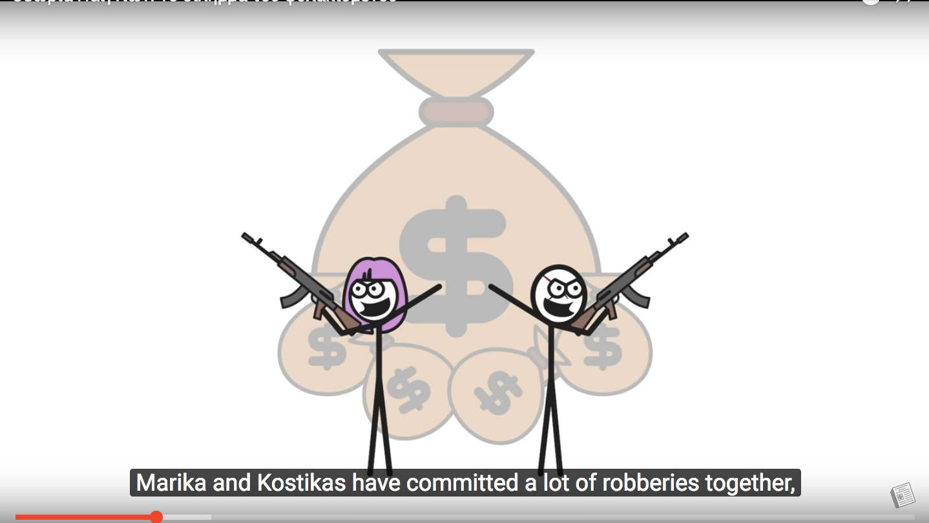

* They are arrested but there is not enough proof against them
* The policemen keep them apart and interrogate them
* The policemen try to make a deal with them
* If they hand in each other, one run free and the is imprisoned for 1 year
* If they do not confess they are both imprisoned for 1 year
* If they both hand each other in , the split the sentence

4. What do they finally choose to do?

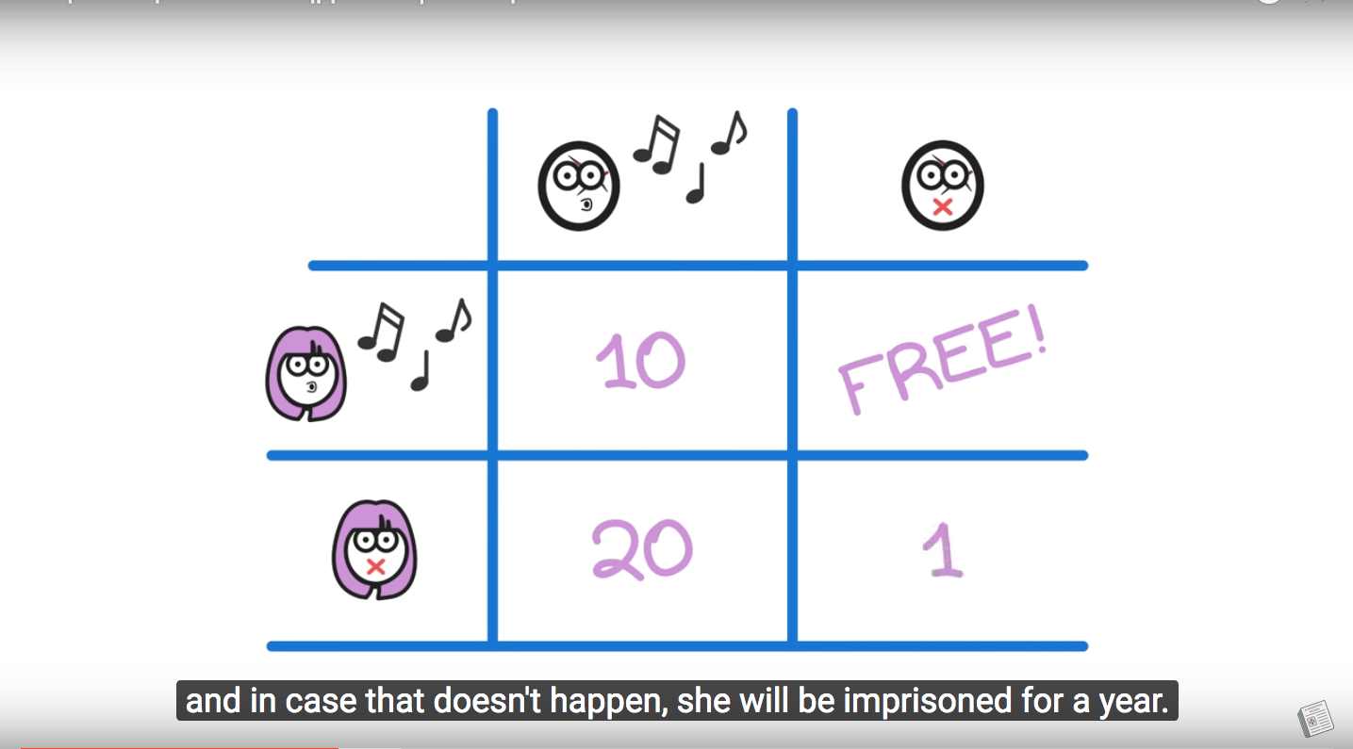

…they choose to hand each other In and split the sentence

……………………………………………………………………………………………………………………………………………………………………………………………………………………………………………………………………………………………………………………………………………………………………………………………………………………………………………………………………………………………………………………………

5. How do you explain their choice?

1. It’s simple maths.
2. It’s a matter of personal interest
3. It’s a matter of luck

6. Was it indeed the best choice for them?

The best choice for both of them is not to confess………………………………………………………………………………………………………………………………………………………………………………………………………………………………………………………………………………………………………………………………………………………………………………………………………………………………………………………………………………………………………………………………

7)Do we come up with such dilemmas in the real world? Can you mention an example given in the video?

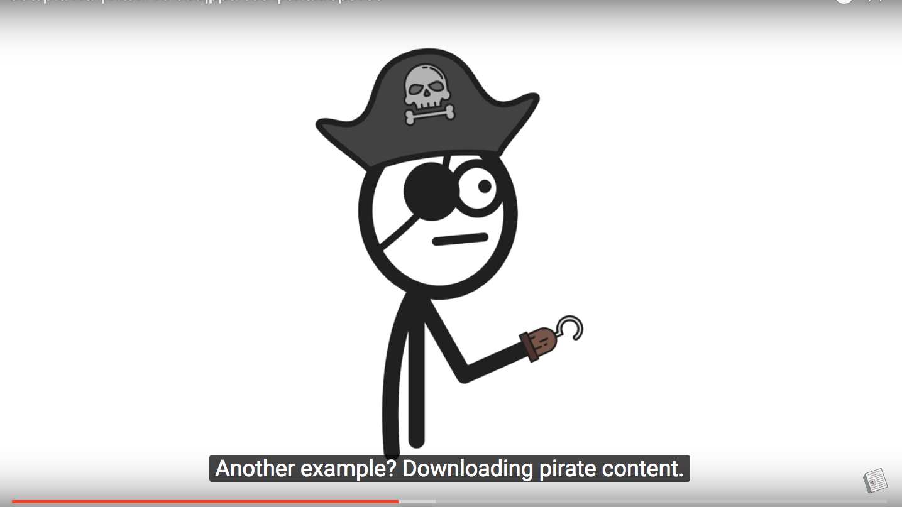

Yes another example given in the video is about climate change ………………………………………………………………………………………………………………………………………………………………………………………………………………………………………………………………………………………………………………………………………………………………………………………………………………………………………………………………………………………………………………………………

8) Can you think of another case of the Prisoner’s dilemma in our life?

If they hand each other in they…will be swimming with the fishes according to the godfather……………………………………………………………………………………………………………………………………………………………………………………………………………………………………………………………………………………………………………………………………………………………………………………………………………………………………………………………………………………………………………………………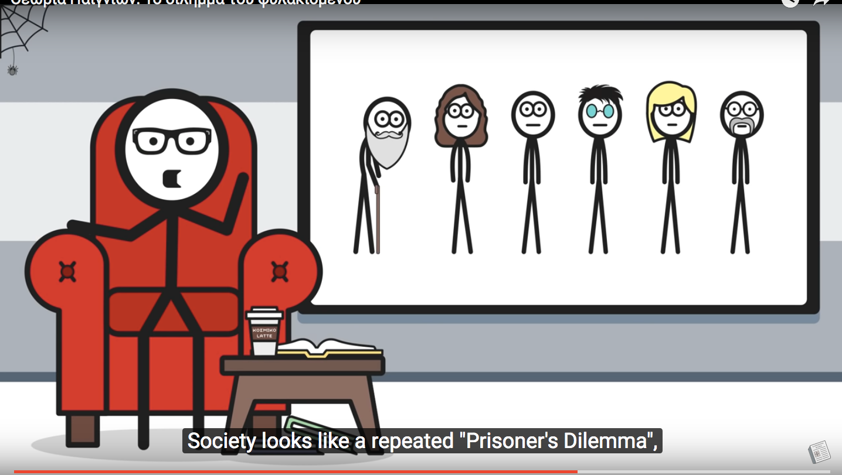

9) The real world reacts to such dilemmas through organised society, to give practical solutions such as the Law and order enforcement. Does the “boogeyman scare” always work? What happens according to Robert Axelrod’s “The Evolution of Cooperation” ?

1. We never cooperate
2. We cooperate at first and expect others to react the same
3. If start showing good will but cheat afterwards

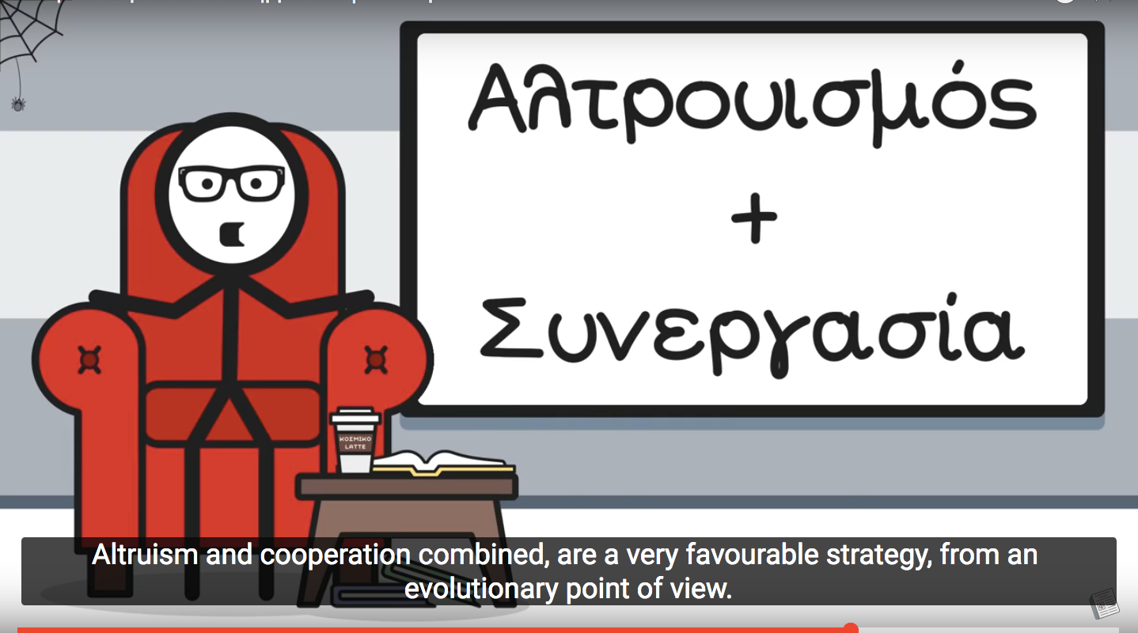

10) What is the best attitude for all species , the human kind included?

It is to cooperate with each other………………………………………………………………………………………………………………………………………………………………………………………………………………………………………………………………………………………………………………………………………………………………………………………………………………………………………………………………………………………………………………………………

11) Can you explain the words?Look them up in the online dictionary [www.glosbe.com](http://www.glosbe.com) and write down the definition given.

altruism=disinterested and selfless concern for the well-being of others.

cooperation= the action or process of working together to the same end.

boogeyman scare=  the emotion experienced in the presence or threat of danger

snitch= inform on someone.

tit for tat= the infliction of an injury or insult in return for one that one has suffered.

dilemma= a situation in which a difficult choice has to be made between two or more alternatives, especially ones that are equally undesirable.

**ABOUT THE VIDEO:**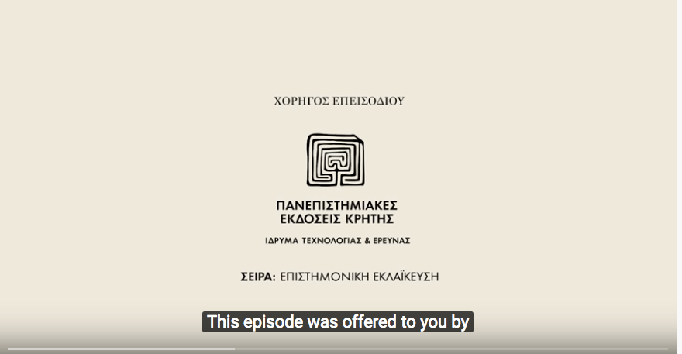

Who created this video?

…Καθημερινή Φυσική ……………………………………………………………

……………………………………………………………..

……………………………………………………………..

………………………………………………………………

What is its purpose?

To talk about the dilemmas people face in the daily lives ………………………………………………………………………………………………………………………………………………………………………………………………………………………………………………………………………………………………………………………………………………………………………………………………………………………………………………………………………………………………………………………………

Have you understood the “ Prisoner’s Dilemma” watching the video or would it be better to read a text about it?

Yes I have ………………………………………………………………………………………………………………………………………………………………………………………………………………………………………………………………………………………………………………………………………………………………………………………………………………………………………………………………………………………………………………………………

Has reading the english subtitles while listening to the greek narrative helped you learn new words?

………………………yes it has ………………………………………………………………………………………………………………………………………………………………………………………………………………………………………………………………………………………………………………………………………………………………………………………………………………………………………………………………………………………………………

What are the main features of the video? Tick them.

1. sound
2. text
3. animation
4. photos
5. links
6. narration
7. subtitles
8. humor