1. **Imagine that you work as a paramedic and the Head of the Emergency Services has asked you to write a report about the steps you took in a life-threatening medi- cal emergency that required immediate attention. Write a report (140-180 words) to illustrate what kind of a medical emergency it was, how the incident occurred, how many people were involved, what symptoms the victims displayed and what kind of first aid was offered.**



First Aid

2

**To:** ................................................................................................................

**From:** ............................................................................................................

**Subject:** ......................................................................................................

**Date:** ..............................................................................................................

The purpose of this report is to ................................................

(Subheading 1) ....................................................................................................................................................................

.................................................................................................................................................................................................

(Subheading 2) ....................................................................................................................................................................

.................................................................................................................................................................................................

(Subheading 3) ....................................................................................................................................................................

.................................................................................................................................................................................................

(Subheading 4) ....................................................................................................................................................................

.................................................................................................................................................................................................

42

43





1. ****✓ **Brainstorm some more cases that might require first aid.**



**group work**

* + **Choose one or two of the above cases and make a list of the things you can do to help. You can search the internet for First Aid tips and instructions.**

**Make a list with the skills that the Emergency Care Assistants/professionals should have. Make a poster with your suggestions and present it to your classmates.**



✓

The Star of Life, a global symbol of emergency medical service

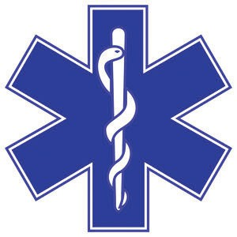

1. **Discuss the following issue.**



**class**

**discussion**

personnel training

First Aid

2

**The City Council are planning to organise local Emergency Services so as to provide medical help in the wider area. They have asked your help and your expert opinion on the project. Read the suggestions in the following spidergram. Classify them according to their priority justifying your answers.**

EMERGENCY

MEDICAL SERVICES

transportation to hospital

organise

health care settings

upskilled training on life support

help by volunteers

1. **a.** Do you think that first aid should be part of the Greek Curriculum so that everyone is prepared to offer help in emergency cases?

**b.** Is it feasible to create a culture of volunteering in order to connect human crisis with human kindness?



44