1. When did the incident described happen and who was the victim?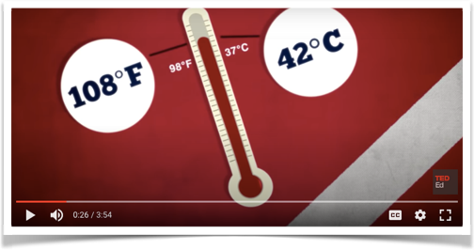

1. In 1985 , an athlete
2. In ancient times, 167 athletes

2. Give the specific details of the person and the situation

……………………………………………………………………………………………………………………………………………………………………………………………………………………………………………………………………………………………………………………………………………………………………………………………………………………………………………………………………………………………………………………………..

3. Check the symptoms that appeared

a) headache

b) vomit

c) very high temperature

d) lack of consciousness

e) muscle pain

f) dizziness

4. The incident wasn’t fatal and the person received proper care.

a)TRUE

b)FALSE

5. A classical heat stroke usually concerns

1. athletes and warriors
2. infants and the elderly

6. What is the difference with exertional heat stroke?

………………………………………………………………………………………………………………………………………………………………………………………………………………………………………………………………………………………………………………………………………………………………………………………………………………………………………………………………………………………………………………………………

7. What happens when we exercise? TRUE or FALSE

1. 80% of the energy is transformed to heat
2. That is called uncompensable heat stress
3. Our body relieves itself by cooling through sweat
4. Through uncompensable heat stress our body temperature raises beyond normal
5. When proteins denature our cells work properly
6. It;s dangerous when leaky cells multiply in our body

8. Mention possible health damage of the situation above

a)

b)

c)

d)

9. How do we diagnose an exertional heat stroke? Check the correct choices

1. Body temperature higher than 40degrees C
2. High blood pressure
3. Faster heartbeat
4. difficult in breathing
5. aggressive behavior
6. confusion
7. intense headaches

10. Why should we use a rectal thermometer?

……………………………………………………………………………………………………………………………………………………………………………………………………………………………………………………………………………………………………………………………………………………

11. Should we transport the patient immediately?

1. Yes, as soon as possible
2. No, cool first then transport

12. What is the ideal way of cooling?

…………………………………………………………………………………………………………………………………………………………………………………………………………………………………………………………………………………………………………………………………………………….

13. Mention an alternative of cooling

………………………………………………………………………………………………………………………………………………………………………………………………………………………………………………………………………………………………………………………………………………………………………………………………………………………………………………………………………………………………………………………………

14. Should we call Emergency Medical Services?

1. Yes , the soonest possible
2. No, most important to get first aid on the spot

15. Are heat strokes a cause of death in sports?

1. Not very common, it’s survivable
2. Yes, one of the top three