# MYTHS AND MISCONCEPTIONS ABOUT FOOD AND NUTRITION

**Health Classes were popular in America since the age of President**

**……………………………………………**

Text

Text

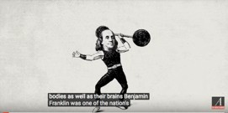

1. What are the goals of Health Class in schools?
2. stay fit & eat right
3. lose weight
4. take in basic knowledge about medication
5. Is there a Health Class in your school? …………………………………

yes

1. The curriculum
2. stays the same
3. older curriculum is rejected
4. 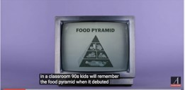needs regular update
5. Food pyramid appeared in schools in
6. the 80’s
7. the 90’s

c. 2000

1. According to the first version it allowed
2. …………….. servings of bread and ……………………., rice and every day
3. It did not separate ……………. grains from grains
4. It recommended ………………

such as poultry, fish and nuts were as healthy as

……………..meat.

1. Nowadays eating too much

……………meat is linked to

……………….., heart and

some cancers.

1. It suggested we use occasionally fats, and

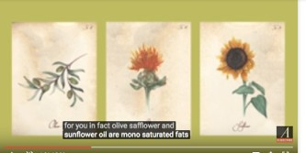……………

f.Still , nowadays , plant oils such as oil are

mono fats and

help cholesterol

1. By 2000 the food pyramid was evaluated as (more than one answers)
2. inaccurate
3. confusing
4. effective
5. misleading
6. expensive
7. Carbo overloaded

It also failed to point to the raising problem of in young children in the USA.

1. The differences between the older and the 2005 version of food pyramid were
2. more text
3. vertical bands
4. more color
5. less food images



1. Who gets involved giving nutrition guidelines in schools?
2. citizens
3. food producers
4. food manufacturers
5. dieticians
6. parents
7. By 2011 the pyramid was replaced by ……………………………
8. The plate is ……………….than the pyramid. ……………..of it is filled with fruit and ,

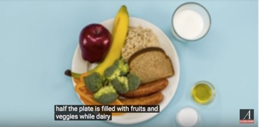dairy is left ………………., oil and sweets ,

1. Is everything

clear today?

…………………………

1. Which of the following still stands true today?
   1. avoid eggs - they cause cholesterol
   2. avoid butter
   3. fitness helps us stay healthy
   4. aerobics helps keep weight down
   5. a mix-up of different intensity workout is best
   6. exercise makes us eat more
2. Health class is not about information but developing healthy routines in our

diet and …………….. that we can ……………………..

