Biodiversity of Attica
Biodiversity of Attica
The region of Attica is the most densely populated region of the country.
It also includes the islands of Salamina, Aegina, Hydra, Poros, Spetses, Kythera as well as the province of Troizenia in the Peloponnese. Its shores have a strong relief and the climate is temperate and pleasant. Athens is the economic, administrative, and cultural center of the country.
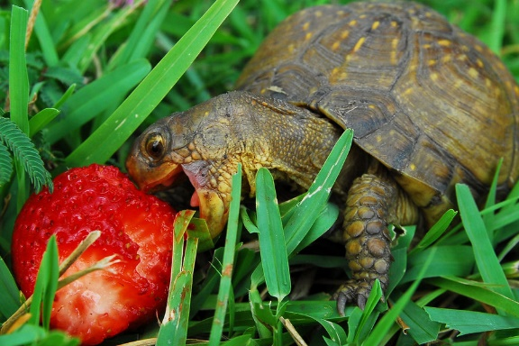
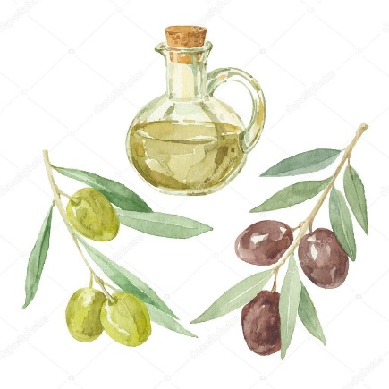

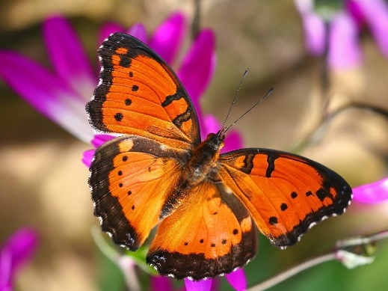

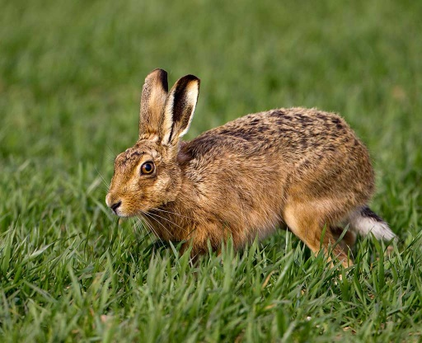
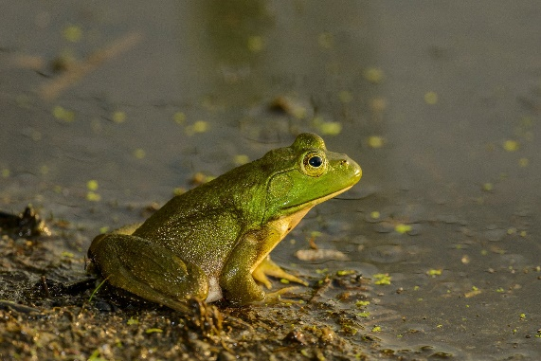

District seat
Athens
Largest city
Athens
Greater river
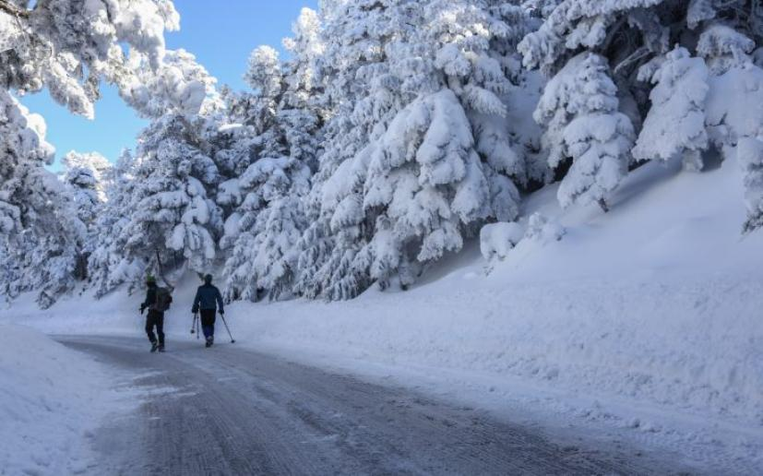
Asopus(on the border of Boeotia)
Highest mountain
Parnitha(1,413m.)
Population
3.792.469 inhabitants)
2) Donkey
The donkey belongs to the same family as the and the zebra, but compared to its relatives it has a smaller height and larger small ears, in the Greek countryside, thanks to its great endurance and strength, it was a valuable helper of the farmer.

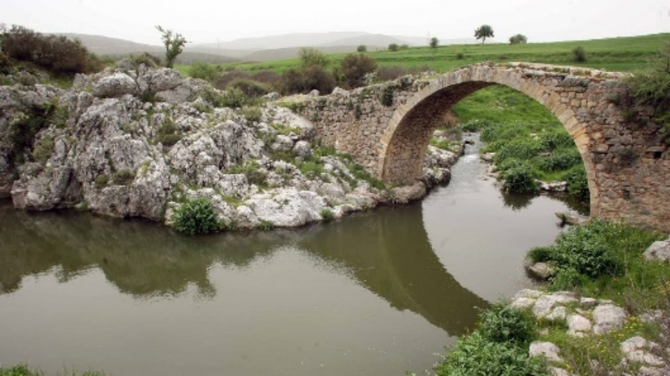
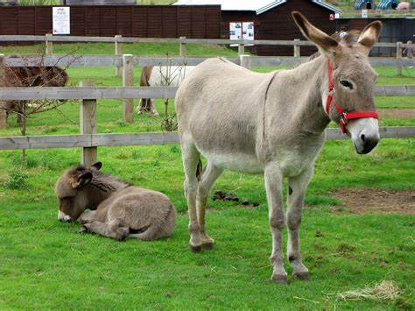
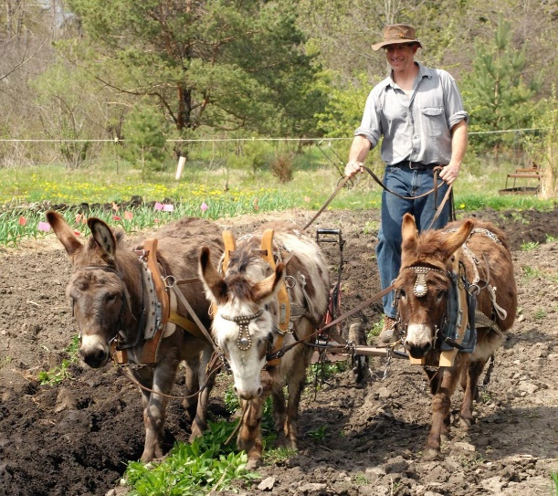
3) Owl
A nocturnal predator, which in ancient times was associated with the worship of the goddess Athena and to this day symbolizes wisdom. It lives in forests, fields and even in the suburbs of cities. It has acute hearing and vision and feeds on small mammals.
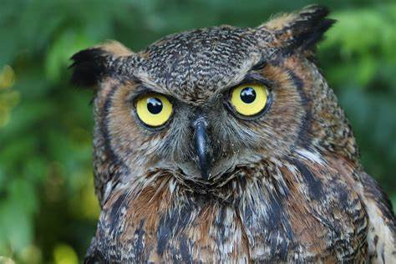

C΄1
Panagiotis V.

