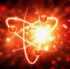
CHEMICAL ENERGY
Chemical energy is defined as the set of potential energy required by various atoms to from molecules of chemical substances, under the interaction of electromagnetic forces or stored in chemical compounds. Also as chemical energy there is an electromagnetic force that is stored.
Chemical energy is usually attributed as thermal energy or electrical energy, when molecules are broken down again into atoms or transformed in organisms into thermal and kinetic energy, by biological mechanisms, and is thus called animal energy.
Chemical energy is due to the bond forces, the attractions of molecules and subatomic particles, the movements of atoms, molecules and electrons. It is, in other words, a combination of kinetic and potential energy. Chemical energy is a “hidden” form of energy and some of it can be easily and sometimes difficult to be released into the environment.
During chemical reactions the chemical energy of the system changes. The results is to release or absorb, energy equal to the difference of the chemical energies of the initial and final substances. This is true, because in chemical reactions not only mass is over but also energy.
The energy released or absorbed in a chemical reaction can take various forms, such as thermal energy, electrical energy, light energy. The conversion of chemical energy into electrical energy is examined by the branch of chemistry called electrochemistry , while the conversion of chemical energy into light energy is examined by photochemistry. Finally, thermochemistry studies the conversions of chemical energy into thermal energy, which are also the most common.

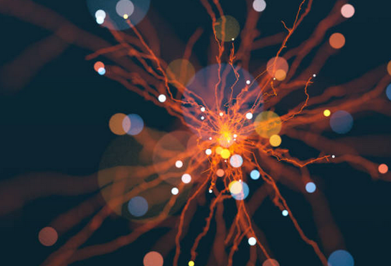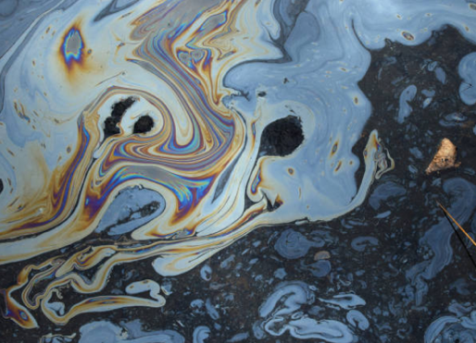
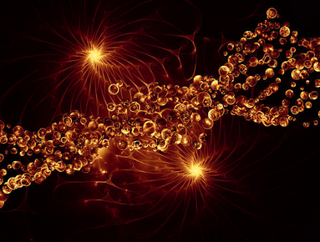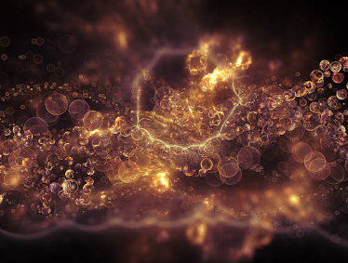

Νικολέτα Ταβουλάρη Γ5

