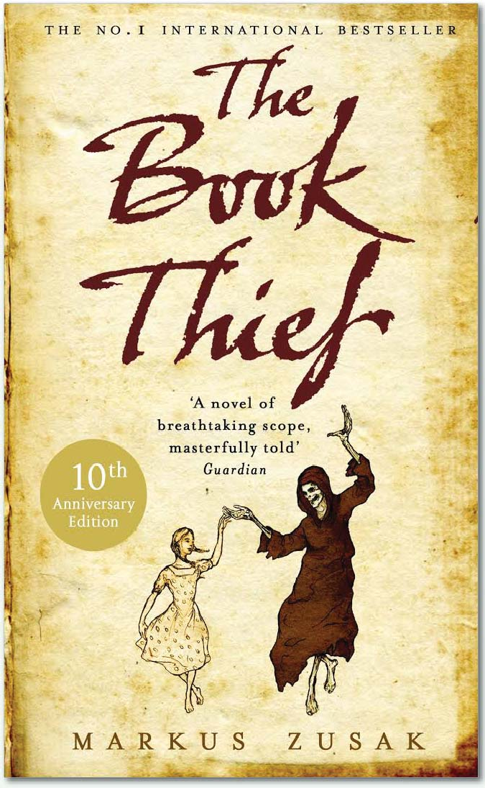
An extract from the book
The Book Thief by Markus Zusak.

“Shouldn’t you be getting ready, Liesel?” Don’t
you have a bonfire to go to?”
“Yes, Papa.”
The book thief went and changed into her
Hitler Youth uniform, and half an hour later,
they left, walking to the BDM headquarters.
From there, the children would be taken to the
town square in their groups.
Speeches would be made. A fire would be lit.
A book would be stolen.
* * *
People lined the streets as the youth of Germany marched toward the town hall and the square. On quite a few occasions Liesel forgot about her mother and any other problem of which she currently held ownership. There was a swell in her chest as the people clapped them on. Some kids waved to their parents, but only briefly— it was an explicit instruction that they march straight and don’t look or wave to the crowd.
When Rudy’s group came into the square and was instructed to halt, there was a discrepancy. Tommy Müller. The rest of the regiment stopped marching and Tommy plowed directly into the boy in front of him.
Dummkopf!” the boy spat before turning around.
“I’ m sorry,” said Tommy, arms held apologetically out. His face tripped over itself. “I couldn’t hear.”

It was only a small moment, but it was also a preview of troubles to come. For Tommy. For Rudy.

At the end of the marching, the Hitler Youth divisions were allowed to disperse. It would have been near impossible to keep them all together as the bonfire burned in their eyes and excited them. Together, they cried one united “heil Hitler” and were free to wander. Liesel looked for Rudy, but once the crowd of children scattered, she was caught inside a mess of uniforms and high-pitched words. Kids calling out to other kids.

By four-thirty, the air had cooled considerably.

People joked that they needed warming up. “That’s all this trash is good for anyway.”
Carts were used to wheel it all in. It was dumped in the middle of the town square and dowsed with something sweet. Books and paper and other material would slide or tumble down, only to be thrown back onto the pile. From further away, it looked like something volcanic. Or something grotesque and alien that had somehow landed miraculously in the middle of town and needed to be snuffed out, and fast.

The applied smell leaned toward the crowd, who were kept at a good distance. There were well in excess of a thousand people, on the ground, on the town hall steps, on the rooftops that surrounded the square.

When Liesel tried to make her way through, a crackling sound prompted her to think that the fire had already begun. It hadn’t. The sound was kinetic humans, flowing, charging up.
They’ve started without me!

Although something inside told her that this was a crime—after all, her three books were the most precious items she owned—she was compelled to see the thing lit. She couldn’t help it. I guess humans like to watch a little destruction. Sand castles, houses of cards, that’s where they begin. Their great skill is their capacity to escalate.

The thought of missing it was eased when she found a gap in the bodies and was able to see the mound of guilt, still intact. It was prodded and splashed, even spat on. It reminded her of an unpopular child, forlorn and bewildered, powerless to alter its fate. No one liked it. Head down. Hands in pockets. Forever. Amen.

Bits and pieces continued falling to its sides as Liesel hunted for Rudy. Where is that Saukerl?

When she looked up, the sky was crouching.

A horizon of Nazi flags and uniforms rose upward, crippling her view every time she attempted to see over a smaller child’s head. It was pointless. The crowd was itself. There was no swaying it, squeezing through, or reasoning with it. You breathed with it and you sang its songs. You waited for its fire.

Silence was requested by a man on a podium. His uniform was shiny brown. The iron was practically still on it. The silence began.

His first words: “Heil Hitler!”
His first action: the salute to the Führer.
“Today is a beautiful day,” he continued. “Not only is it our great leader’s birthday—but we also stop our enemies once again. We stop them reaching into our minds...”

Liesel still attempted to fight her way through.

“We put an end to the disease that has been spread through Germany for the last twenty years, if not more!”

He was performing now what is called a Schreierei—a consummate exhibition of passionate shouting—warning the crowd to be watchful, to be vigilant, to seek out and destroy the evil machinations plotting to infect the mother-land with its deplorable ways.

“The immoral! The Kommunisten !”

That word again. That old word. Dark rooms. Suit-wearing men.

“Die Juden—the Jews!”

Halfway through the speech, Liesel surrendered. As the word communist seized her, the remainder of the Nazi recital swept by, either side, lost somewhere in the German feet around her.

Waterfalls of words. A girl treading water. She thought it again. Kommunisten.

Up until now, at the BDM, they had been told that Germany was the superior race, but no one else in particular had been mentioned. Of course, everyone knew about the Jews, as they were the main offender in regard to violating the German ideal. Not once, however, had the communists been mentioned until today, regardless of the fact that people of such political creed were also to be punished.

She had to get out.

In front of her, a head with parted blond hair and pigtails sat absolutely still on its shoulders. Staring into it, Liesel revisited those dark rooms of her past and her mother answering questions made up of one word.

She saw it all so clearly.

Her starving mother, her missing father. Kommunisten.

Her dead brother.

“And now we say goodbye to this trash, this poison.”

Just before Liesel Meminger pivoted with nausea to exit the crowd, the shiny, brown shirted creature walked from the podium. He received a torch from an accomplice and lit the mound, which dwarfed him in all its culpability. “ Heil Hitler!”

The audience: “Heil Hitler!”

A collection of men walked from a platform and surrounded the heap, igniting it, much to the approval of everyone. Voices climbed over shoulders and the smell of pure German sweat struggled at first, then poured out. It rounded corner after corner, till they were all swimming in it. The words, the sweat. And smiling.

Let’s not forget the smiling. Many jocular comments followed, as did another onslaught of “heil Hitlering.” You know, it actually makes me wonder if anyone ever lost an eye or injured a hand or wrist with all of that. You’d only need to be facing the wrong way at the wrong time or stand marginally too close to another person. Perhaps people did get injured. Personally, I can only tell you that no one died from it, or at least, not physically. There was, of course, the matter of forty million people I picked up by the time the whole thing was finished, but that’s getting all metaphoric. Allow me to return us to the fire.

The orange flames waved at the crowd as paper and print dissolved inside them. Burning words were torn from their sentences.

On the other side, beyond the blurry heat, it was possible to see the brownshirts and swastikas joining hands. You didn’t see people. Only uniforms and signs.

Birds above did laps.

They circled, somehow attracted to the glow— until they came too close to the heat. Or was it the humans? Certainly, the heat was nothing.

In her attempt to escape, a voice found her.

“Liesel!”

It made its way through and she recognized it. It was not Rudy, but she knew that voice.

She twisted free and found the face attached to it. Oh, no. Ludwig Schmeikl. He did not, as she expected, sneer or joke or make any conversation at all. All he was able to do was pull her toward him and motion to his ankle. It had been crushed among the excitement and was bleeding dark and ominous through his sock. His face wore a helpless expression beneath his tangled blond hair. An animal. Not a deer in lights. Nothing so typical or specific. He was just an animal, hurt among the melee of its own kind, soon to be trampled by it.

Somehow, she helped him up and dragged him toward the back. Fresh air.

They staggered to the steps at the side of the church. There was some room there and they rested, both relieved.

Breath collapsed from Schmeikl’s mouth. It slipped down, over his throat. He managed to speak. Sitting down, he held his ankle and found Liesel Meminger’s face. “Thanks,” he said, to her mouth rather than her eyes. More slabs of breath. “And . . .” They both watched images of school-yard antics, followed by a school-yard beating. “I’m sorry—for, you know.”

Liesel heard it again.

Kommunisten.

She chose, however, to focus on Ludwig Schmeikl. “Me too.”

They both concentrated on breathing then, for there was nothing more to do or say. Their business had come to an end.

The blood enlarged on Ludwig Schmeikl’s ankle.

A single word leaned against the girl.

To their left, flames and burning books were cheered like heroes.

She remained on the steps, waiting for Papa, watching the stray ash and the corpse of collected books. Everything was sad. Orange and red embers looked like rejected candy, and most of the crowd had vanished. She’d seen Frau Diller leave (very satisfied) and Pfiffikus (white hair, a Nazi uniform, the same dilapidated shoes, and a triumphant whistle). Now there was nothing but cleaning up, and soon, no one would even imagine it had happened.
But you could smell it.

An extract from the book The Book Thief by Markus Zusak. London: Transworld Publishers, 2007, pp. 113-120 Film poster: http://www.imdb.com Book cover: http://www.amazon.com

