**Why Are there different blood types?**

1. “We all the same blood”. Blood is common in all mankind.
2. Still the phrase is: a) true b) accurate c) inaccurate
3. Our contain a protein called hemoglobin.
4. Antigens are also on the outside of the cell membranes.
5. White blood cells relate to our immune system to fight ………………….
6. Antigens and hemoglobin relate to the circulating of in our body.
7. 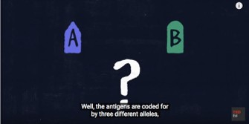Thanks to antigens our body identifies its a) own cells b) foreign bodies c) viruses
8. There are

………….. types

of antigens :

………………. & and they determine our blood type.

1. The antigens are coded by different forming a) two b) more than two c)

less than two blood types

1. The O allele codes for a) both A& B antigens b) neither A nor B c) only A antigen
2. We inherit two genes from each parent that determine our blood type a) TRUE B) FALSE
3. Which alleles are dominant and which one is recessive?
4. 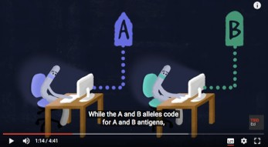Parents’ blood types allow us to guess the children’s blood type A

+A=… , A

+B= , O

+B=… , B

+B=… ,

O+A=……………..,O+O=…………………….

1. Blood types can be a matter of life or death when it comes to …………………………….

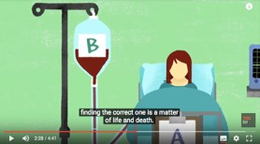

1. Some cultures associate

blood types with a) body type b) star sign c) personality

1. What blood type makes people Universal recipients ?
2. What blood type makes people Universal donors?
3. Recipients and donors must also take into account the antigen factor.
4. Rh+ OR Rh- refers to the absence of the antigen in blood system.
5. Different species have different number of blood types . Give an example.

