WORKSHEET created by Maria Papanikou

**THE GAME THEORY : The Dilemma of the Prisoner**

1. The dilemma of the prisoner is actually a) a book b) an experiment c) a movie based on the The Game Theory.
2. The conclusion is that individual benefit and group benefit a) don’t differ b) always differ c) aren’t the same
3. Check the sentences that describe correctly the conditions of the experiment

* Marika and Kostikas are friends and partners in crime
* Marika and Kostikas are robbers and don’t trust each other

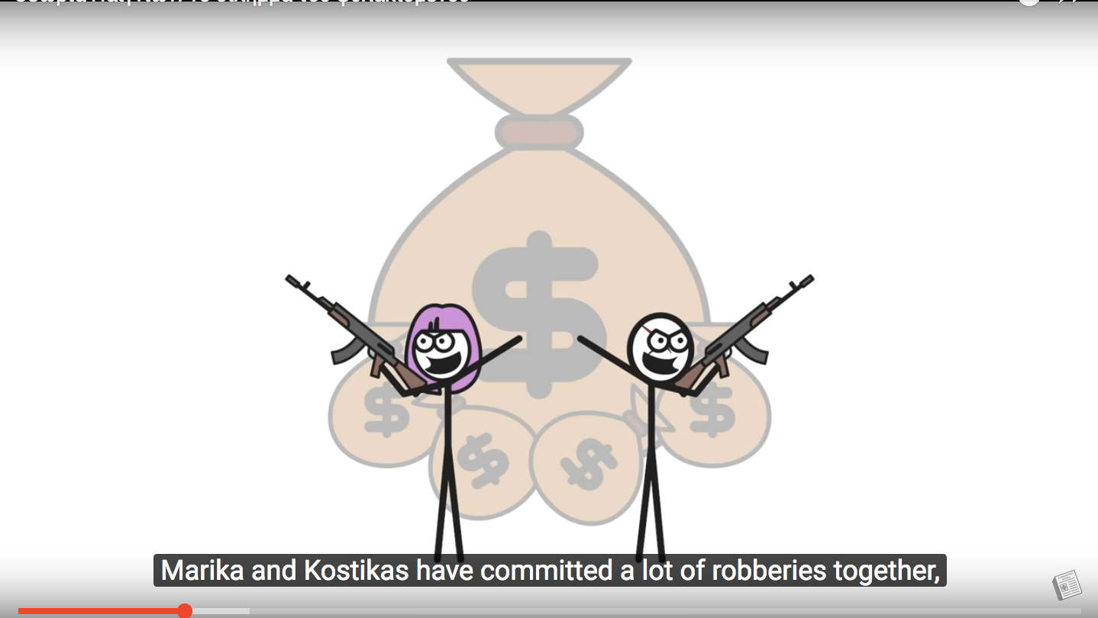

* They are arrested but there is not enough proof against them
* The policemen keep them apart and interrogate them
* The policemen try to make a deal with them
* If they hand in each other, one run free and the is imprisoned for 1 year
* If they do not confess they are both imprisoned for 1 year
* If they both hand each other in , the split the sentence

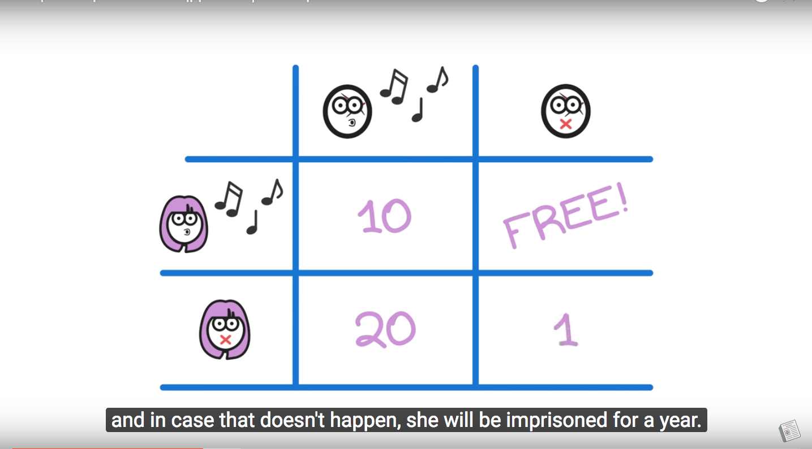

4. What do they finally choose to do?

………………………………………………………………………………………………………………………………………………………………………………………………………………………………………………………………………………………………………………………………………………………………………………………………………………………………………………………………………………………………………………………………

5. How do you explain their choice?

1. It’s simple maths.
2. It’s a matter of personal interest
3. It’s a matter of luck

6. Was it indeed the best choice for them?

………………………………………………………………………………………………………………………………………………………………………………………………………………………………………………………………………………………………………………………………………………………………………………………………………………………………………………………………………………………………………………………………

7)Do we come up with such dilemmas in the real world? Can you mention an example given in the video?

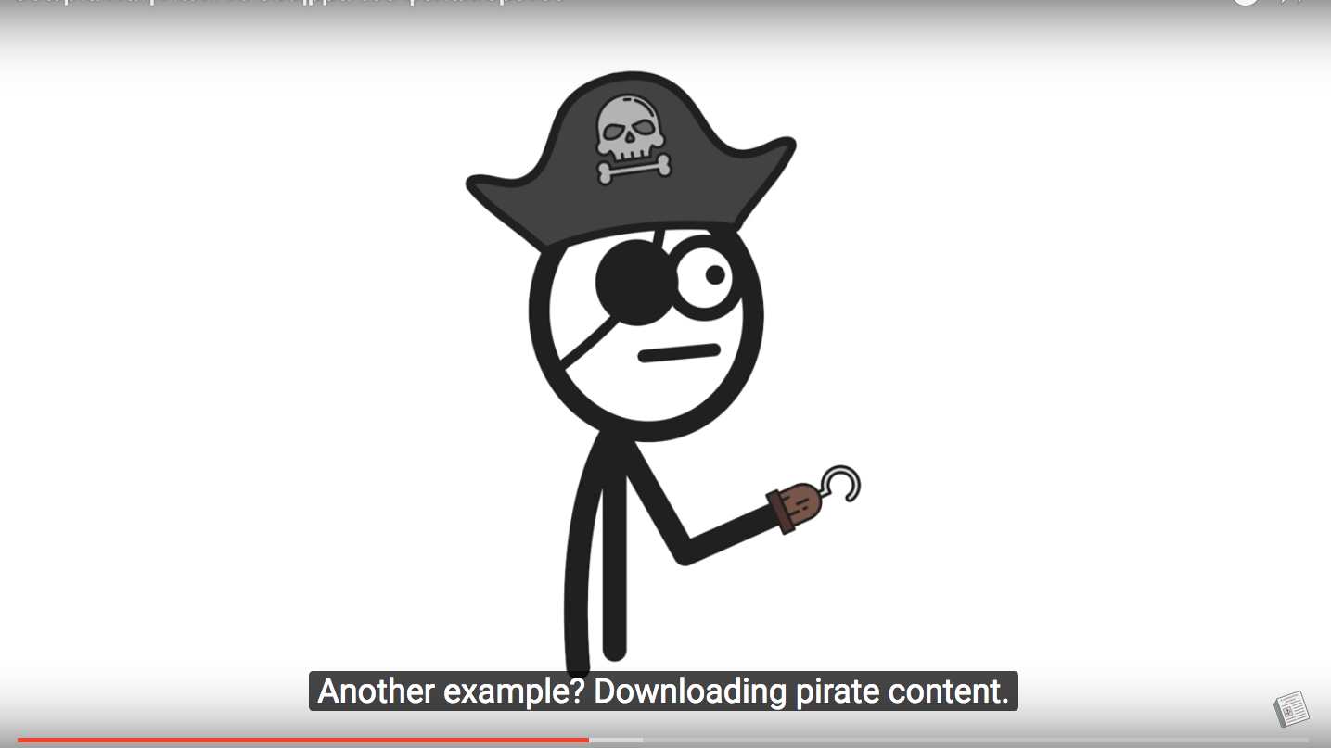

………………………………………………………………………………………………………………………………………………………………………………………………………………………………………………………………………………………………………………………………………………………………………………………………………………………………………………………………………………………………………………………………

8) Can you think of another case of the Prisoner’s dilemma in our life?

………………………………………………………………………………………………………………………………………………………………………………………………………………………………………………………………………………………………………………………………………………………………………………………………………………………………………………………………………………………………………………………………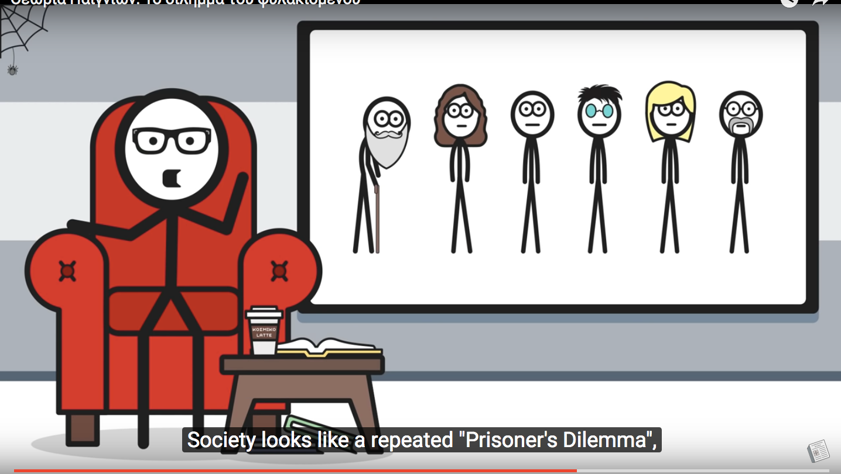

9) The real world reacts to such dilemmas through organised society, to give practical solutions such as the Law and order enforcement. Does the “boogeyman scare” always work? What happens according to Robert Axelrod’s “The Evolution of Cooperation” ?

1. We never cooperate
2. We cooperate at first and expect others to react the same
3. If start showing good will but cheat afterwards

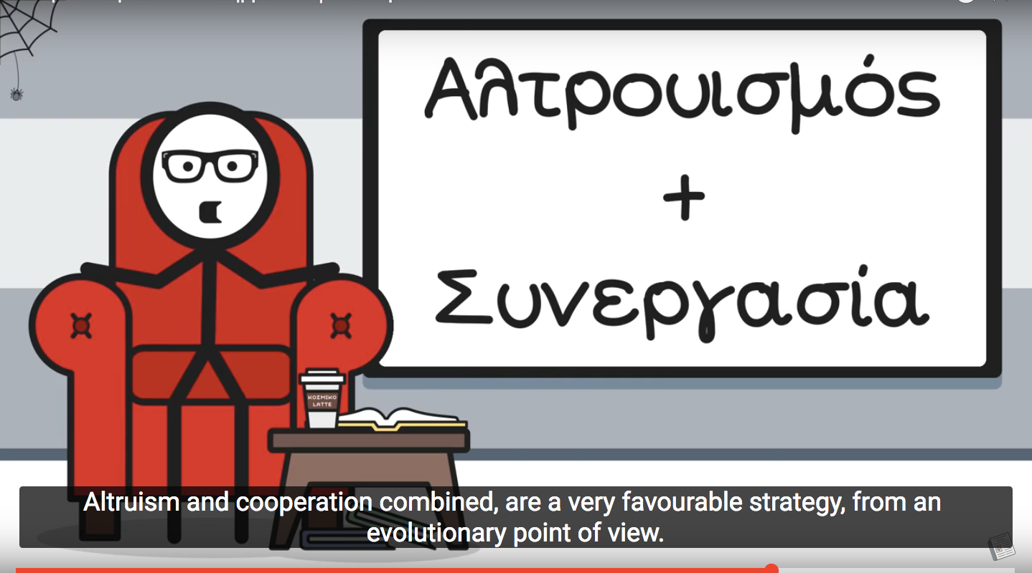

10) What is the best attitude for all species , the human kind included?

………………………………………………………………………………………………………………………………………………………………………………………………………………………………………………………………………………………………………………………………………………………………………………………………………………………………………………………………………………………………………………………………

11) Can you explain the words?Look them up in the online dictionary [www.glosbe.com](http://www.glosbe.com) and write down the definition given.

altruism=

cooperation=

boogeyman scare=

snitch=

tit for tat=

dilemma=

**ABOUT THE VIDEO:**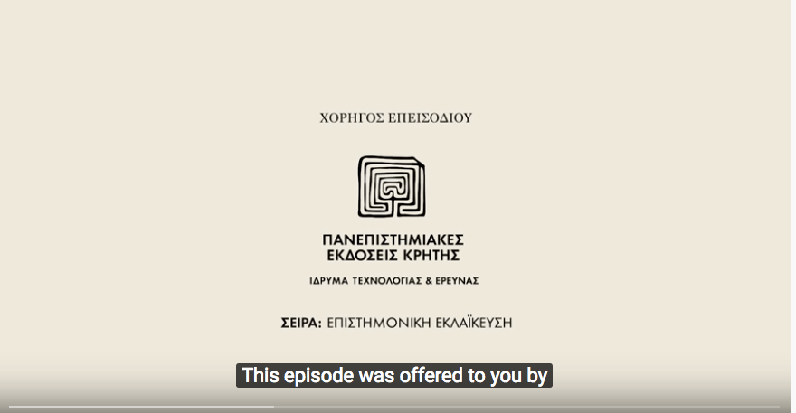

Who created this video?

………………………………………………………………

……………………………………………………………..

……………………………………………………………..

………………………………………………………………

What is its purpose?

………………………………………………………………………………………………………………………………………………………………………………………………………………………………………………………………………………………………………………………………………………………………………………………………………………………………………………………………………………………………………………………………

Have you understood the “ Prisoner’s Dilemma” watching the video or would it be better to read a text about it?

………………………………………………………………………………………………………………………………………………………………………………………………………………………………………………………………………………………………………………………………………………………………………………………………………………………………………………………………………………………………………………………………

Has reading the english subtitles while listening to the greek narrative helped you learn new words?

………………………………………………………………………………………………………………………………………………………………………………………………………………………………………………………………………………………………………………………………………………………………………………………………………………………………………………………………………………………………………………………………

What are the main features of the video? Tick them.

1. sound
2. text
3. animation
4. photos
5. links
6. narration
7. subtitles
8. humor