**WORKSHEET 1: “MAN” by Steve Cutts**

**Watch carefully this innovative and interesting video on man’s attitude towards the planet which hosts him and do the tasks.**

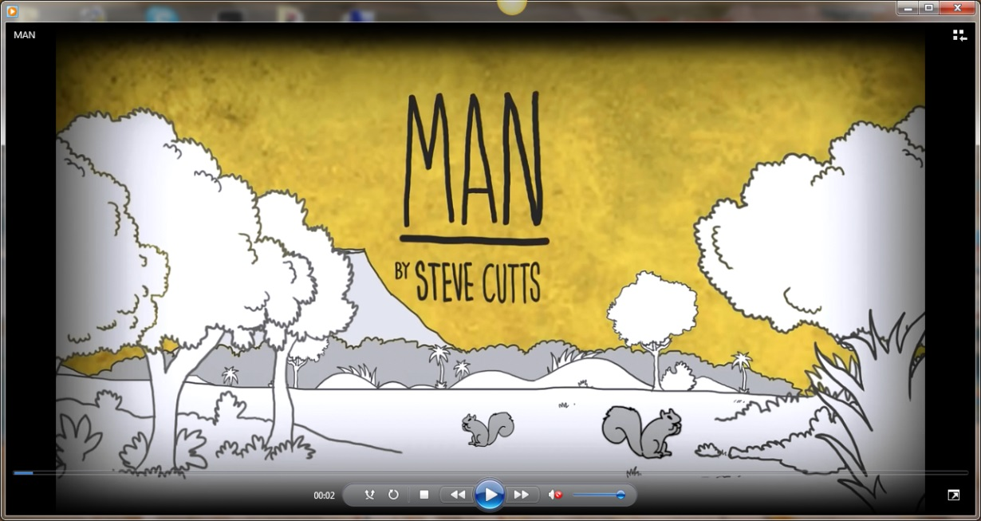

When did man first appear on earth?

………………………………………………………………………………………………………………………………………………………………………………………

What was the first thing he did when he stepped foot on earth?

1. Was welcome by everyone
2. Was curious about everything
3. Came off as a conqueror.

Describe in your own words one of the things he did to the animals that came on his way.

1. The sheep
2. The seal
3. The elephant

**…………………………………………………………………………………………………………………………………………………………………………………………………………………………………………………………………………………………………………………………………………………………………………………………………………………………………………………………………………………………………………………………………………………………………………………………………………………………………………………………………………………………………………………………………………………………………………**

What did he do during his first sail?

1. He dropped all kinds of ………………………….in the sea, mainly ……………………., …………..and bottles.
2. He ………………………. Fish in a net.
3. He …………………………………………..the water.
4. He acted as ……………………of the sea, as written on the boat.
5. He left ………………..dolphins on the beach behind him.

What are the two uses he thought of bears? Fill in the missing words.

He either …………………………………the mother bear OR put the young one on a …………………….act.

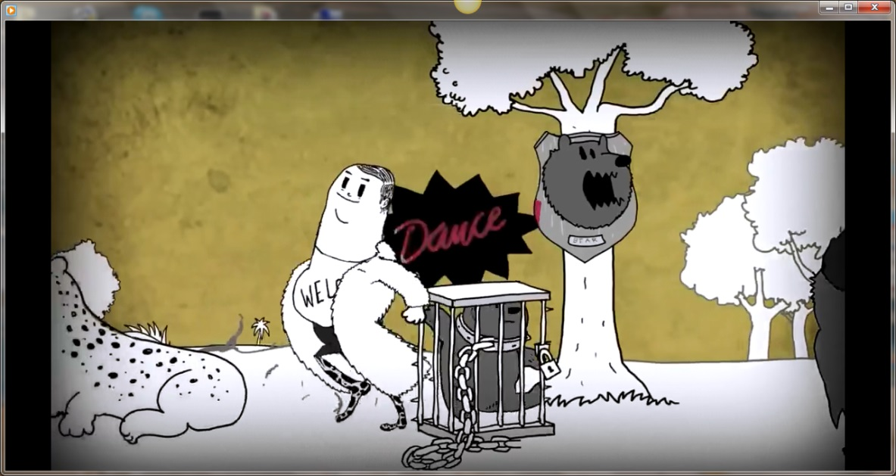

As the Conductor of the orchestra of the world was were his main creations? Answer using the words given.

He made …………………….out of trees, constructed big …………………., ……………………….roads, tons of electrical ……………………………, …………………….pork and …………….meat, he ……………………..on animals creating various …………………….., and ended on top of enormous …………………..of garbage.

Processed, beef, mountains, appliances, paper, multi-level, experimented, mutations, cities.

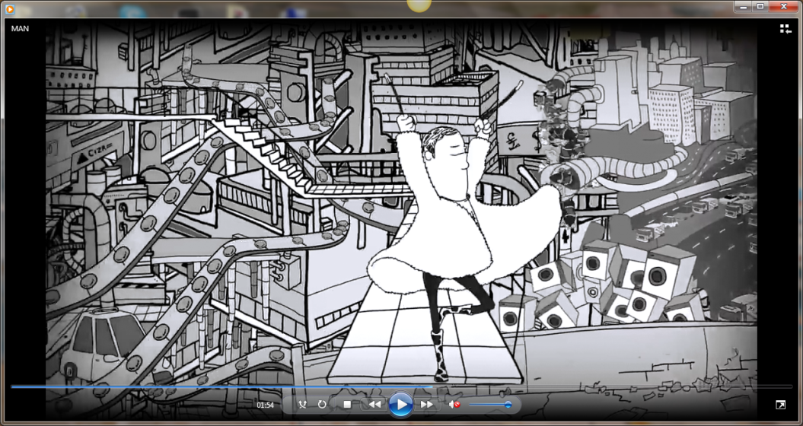

Is he conscious of the terrible disaster he has caused? How does he feel on top of this mess?

…………………………………………………………………………………………………………………………………………………………………………………………………………………………………………………………………………………………………………………………………………………….

Complete your answer describing the picture below.

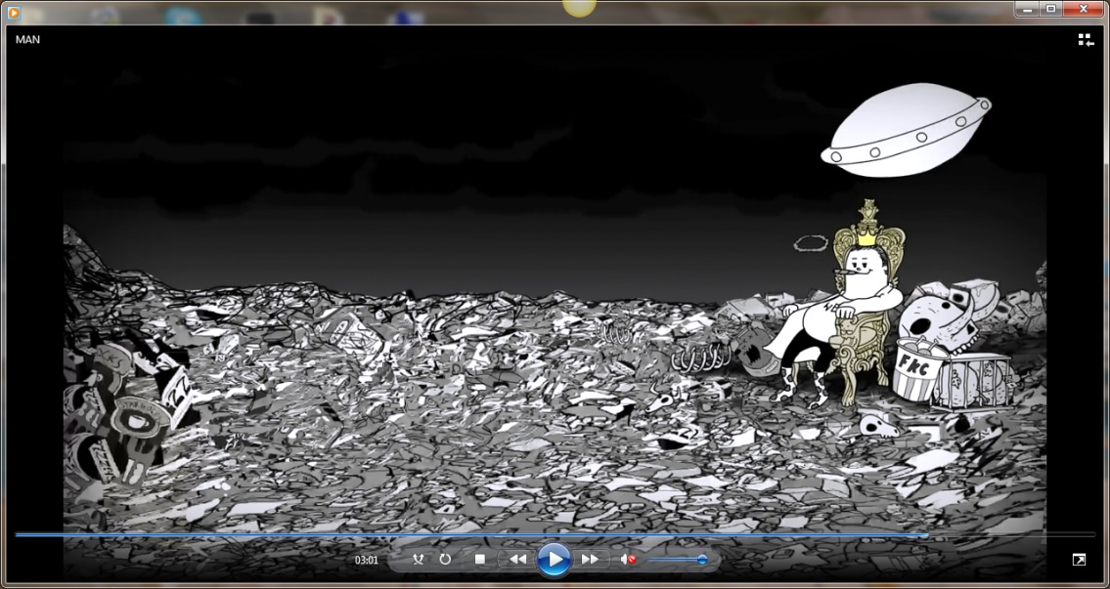

Who arrives in the end of the story? How does the story end?

………………………………………………………………………………………………………………………………………………………………………………………………………………………………………………………………………………………………………………………………………………………………………………………………………………………………………………………………………………………………………………………………

What do you think of the video? Choose the best option(s).

Realistic and interesting

Imaginary and untrue

Modern and humorous

Kid’s animation

Write a text expressing your thoughts and ideas about man’s works on earth and his respect or disrespect to the surrounding environment (using specific examples from the video), and make suggestions about changes we should make and things we’d better do in a different way.

……………………………………………………………………………………………………………………………………………………………………………………………………………………………………………………………………………………………………………………………………………………………………………………………………………………………………………………………………………………………………………………………………………………………………………………………………………………………………………………………………………………………………………………………………………………………………………………………………………………………………………………………………………………………………………………………………………………………………………………………………………………………………………………………………………………………………………………………………………………………….