*THE UK – LAND AND PEOPLE* 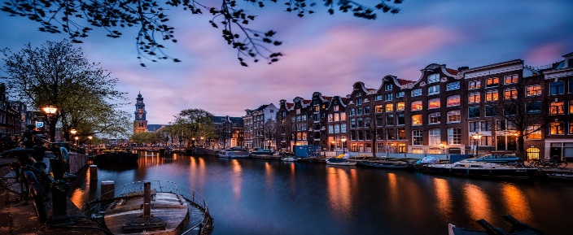

*AMSTERDAM / HOLAND*

I love to learn about different countries but the one country I want to learn more about is Amsterdam.

Amsterdam is situated in a flat and low-lying area mainly on the south bank of the IJ, an inland arm of the former Zuiderzee, now the Ijsselmeer, connected by canal with the North Sea.

Amsterdam also uncover its hidden gems, culinary delights and vibrant neighborhoods. It also has something for everyone to do at leisure time. Also in a cycling adventure, you can explore hidden gems, you can try the best Dutch fries at Vlaminck, you can visit Rijksmuseum and bike underneath its grand façade, you can explore independent shopping streets and more entertaining things.

Amsterdam’s hidden art treasures far beyond the Dutch Masters. From a museum dedicated to microbes to immersive digital art spaces in repurposed factories, the city’s art scene has something for everyone. Also haw exhibitions that blur the lines between science and sculpture, photography and philosophy. Amsterdam’s creative spirit lives not just in its famous museums, but in the places you least expect.

The World Economic Forum ranked the Netherlands at third place in its list of the most educated countries in the world. The education system in the Netherlands works very well. Education is free and open to all so parents do not pay fees for their children secondary education and most textbooks are provided by the school. Children get 8 gears of primary education, 4, 5 or 6 years of secondary education. After secondary school, they can go on to vocational education or higher education.

Amsterdam is also known about its sports. For example, football is the most popular sport in Netherlands, with field hockey and volleyball as the second and third most popular team sports. Speed skating, cycling, tennis and golf are the four most widely played individual sports.